This is a do-it-yourself guide for building a low-cost CO2 sensor system. Each system comprises a control unit and a sensing unit. There are two versions available, with the primary difference being that version 2 includes a modem and a Teros 12 moisture sensor. We have provided Arduino codes for both versions on our GitHub page.

Version 1: <https://github.com/OpenDigiEnvLab/soil-CO2-sensor-system/blob/main/CO2O2Soils_withRelay_6CO2sensors.ino>

Version 2: <https://github.com/OpenDigiEnvLab/soil-CO2-sensor-system/blob/main/CO2O2SoilsTypeB_blues_6CO2Sensors_Teros12_Serial.ino>

The schematic designs of two versions are illustrated in the picture below:

**Version 1:**

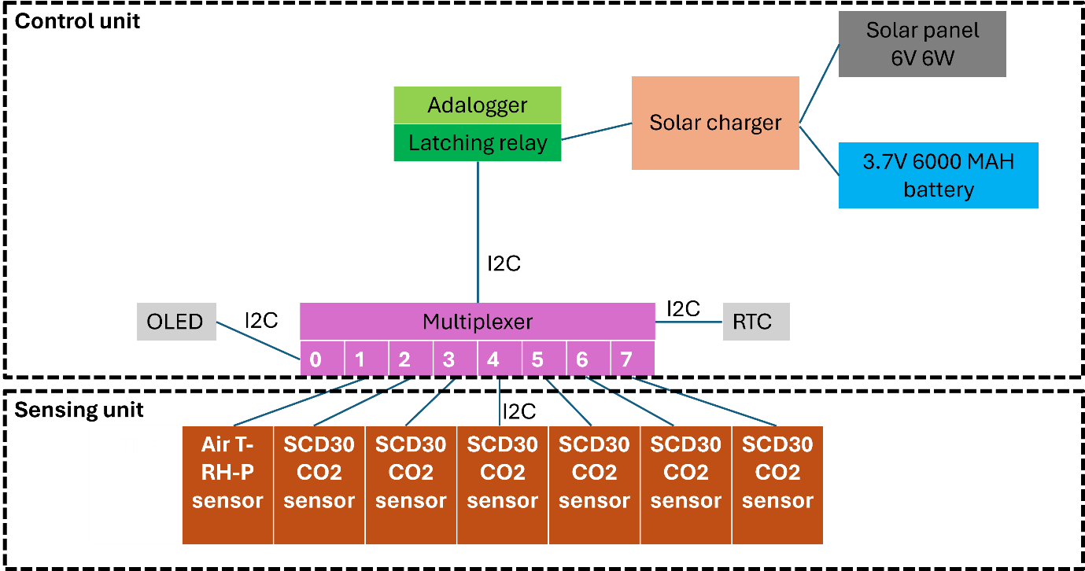

**Version 2:**

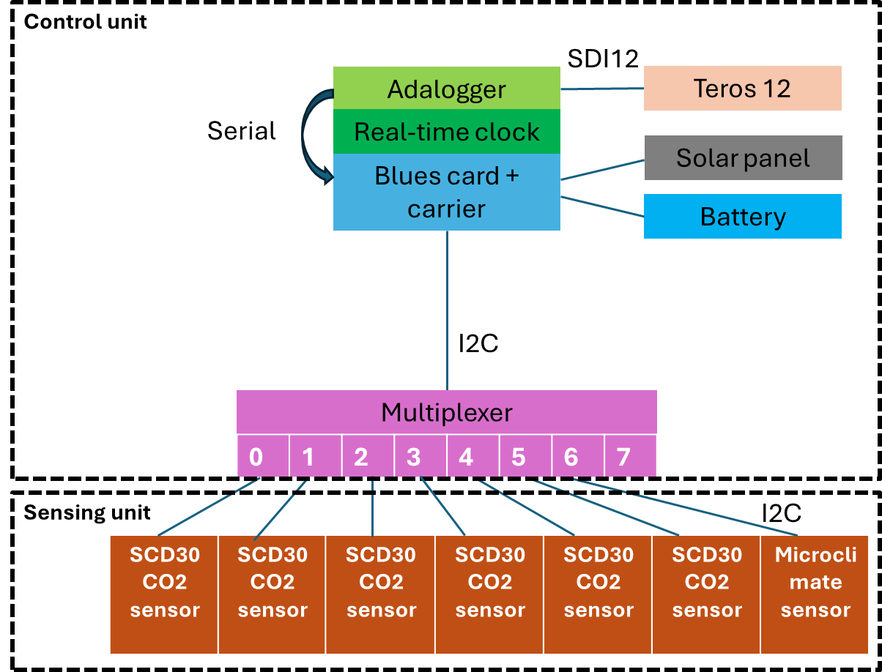

**Protocol**

* 1. **Control unit.**

To replicate the control unit of version 1, prepare the components as listed in Table 1, and follow *procedure (1)*.

To replicate the control unit of version 2, prepare the components as listed in Table 2, and follow *procedure (2)*.

* 1. **Sensing unit**

The procedure to prepare SCD30 CO2 sensors and microclimate sensor are same for both versions.

There is only one additional step to Version 2 as Teros 12 moisture sensor is included in the system.

The preparation of the sensing unit mainly involves waterproof shielding of SCD30 CO2 sensors for underground soil CO2 measurements and wiring SCD30 sensors for the connection to the control unit.

There are two designs of the waterproof shield:

* Thin coating design (TC design): using PTFE membrane and epoxy (or only PTFE membranes)
* 50 ml Falcon tube design (FT design): using a 50 ml Falcon tube.

To replicate the TC design, follow *procedure (3).*

To replicate the FT design, follow *procedure (4).*

|  |  |
| --- | --- |
| TC design | FT design |
|  |  |

* 1. **Connecting the sensing unit to control unit.**
* **Sensing unit to control unit Version 1:**

The wiring map is presented as follow:

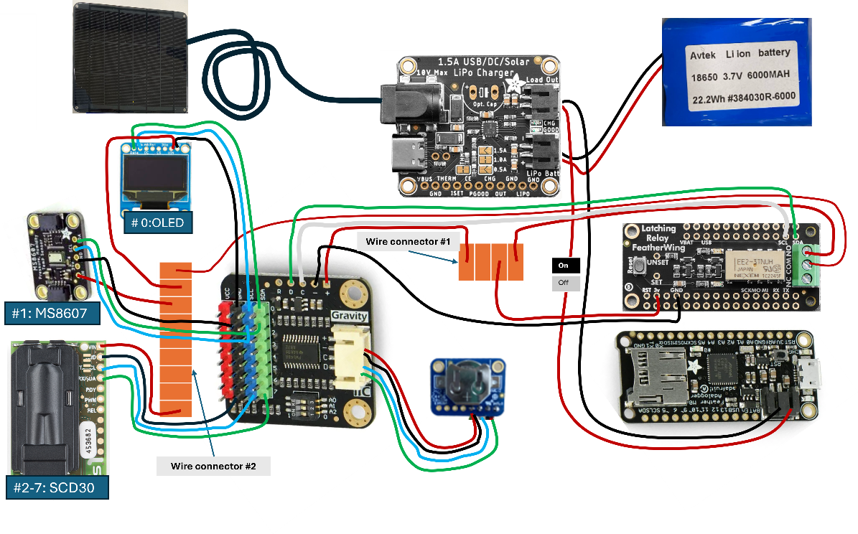

To replicate, follow *procedure (5).*

* **Sensing unit to control unit Version 2:**

Step 1: Simply plug in all the prepared SCD30 sensors and microclimate MS8607 sensor to port 0-6 on multiplexer.

Step 2: Connect the Teros 12 to Adalogger feather M0: the communication type is SDI 12

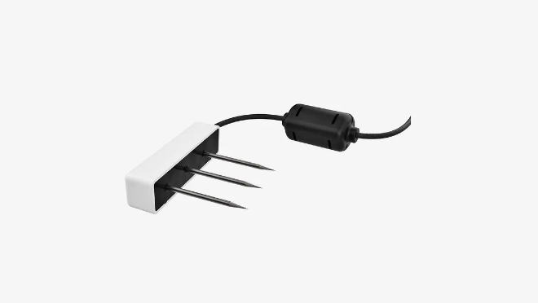 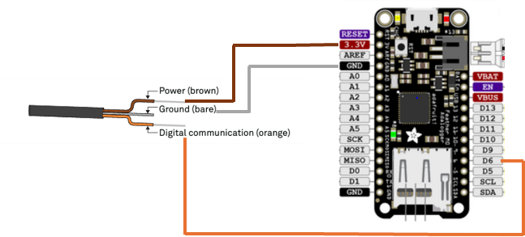

* 1. **To upload Arduino code and test sensors, follow *procedure (6)*.**

**Table 1: Hardware components for CO2 system Version 1.**

|  |  |  |  |  |
| --- | --- | --- | --- | --- |
| **Component** | **Quantify** | **Cost (USD)** | **Sources** | **Comments** |
| **Hardware components for control unit – Version 1** | | | | |
| Feather M0 Adalogger | 1 | 19.95 | [Adafruit](https://www.adafruit.com/product/2796) |  |
| RTC DS3231 with CR1220 battery | 1 | 17.5 | [Adafruit](https://www.adafruit.com/product/3013) | Provides accurate time for the data logger; can be purchased from other suppliers |
| Gravity 1-to-8 I2C Multiplexer | 1 | 6.9 | [DFRobot](https://www.dfrobot.com/product-1780.html#:~:text=1%20multiplexer%20has%208%20I2C,control%2064%20same%2Daddress%20devices.) | Enables the connections of multiple CO2/O2 sensors to one data logger; Can be purchased from other suppliers |
| 0.96" 128x64 OLED Graphic Display | 1 | 17.5 | [Adafruit](https://www.adafruit.com/product/326) | Can be purchased from other suppliers |
| Latching relay FeatherWing | 1 | 7.95 | [Adafruit](https://www.adafruit.com/product/2923) | For power control: programmed to turn on and turn off the system when needed |
| P2886A feather header kit | 1 | 0.95 | [Adafruit](https://www.adafruit.com/product/2886) | To connect Feather M0 Adalogger with Latching relay FeatherWing |
| 3.6V 6000 mAh battery | 1 | 50 | Local suppliers or online (e.g., Amazon) | To provide power for the control and sensor unit |
| Adafruit Universal USB / DC / Solar Lithium Ion/Polymer charger - bq24074 | 1 | 14.95 | [Adafruit](https://www.adafruit.com/product/4755) | To charge the battery using the solar energy from solar panel |
| Medium 6V 2W Solar panel | 1 | 29 | [Adafruit](https://www.adafruit.com/product/200) |  |
| SD/MicroSD memory card (8GB SDHC) |  | 9.95 | [Adafruit](https://www.adafruit.com/product/1294) | Can be purchased from other suppliers |
| **Hardware components for sensing unit – Version 1 + 2** | | | | |
| SCD30 CO2 sensor  (0-10,000ppm, I2C) | 6 | 6 ×61.79 | [Digikey](https://www.digikey.com/en/products/detail/sensirion-ag/SCD30/8445334) | + 4 sensors with thin coating and 2 sensors with falcon tube  + Can be purchased from other suppliers |
| STEMMA QT MS8607 humidity temperature pressure sensor | 1 | 14.95 | [Adafruit](https://www.adafruit.com/product/4716) | To measure atmospheric humidity, temperature, and pressure |
| [50ml Falcon tube](https://www.fishersci.com/shop/products/falcon-50ml-conical-centrifuge-tubes-2/p-193321) | 2 | 1 | Local suppliers or online (e.g., Amazon) | To use for waterproofing SCD30 sensors |
| PTEE membrane 1/16” x 6” x 6” GR Sheets | 1 | 37.97 | [McMaster](https://www.mcmaster.com/ptfe/ultra-chemical-resistant-compressible-ptfe-gasket-material-7/thickness~1-16/) | To use in the waterproofing design, allowing exchange of CO2 between sensors and the environment |
| Cables, wires, and general equipment:  + 7 × 4-wire cable 3m (6 for SCD30 sensors and 1 for MS8607 sensor)  + Wires in colors white, green, red, black  + 8 × [4-pin cables with Female Dupont connectors](https://www.amazon.de/-/en/Pin-Dupont-Cable-Female-Connector/dp/B01B360810)  + 3 × [JST PH 2pin cable-male connector](https://www.adafruit.com/product/3814)  + 1× [4pin PH2.0 cable-male connector](https://www.dfrobot.com/product-2554.html)  + 2 lever wire connectors  + on/off switch  + shrinking sleeves different sizes |  | ~30 | Local suppliers or online (e.g., Amazon) |  |
| Epoxy | 500 gram | 10 | Local suppliers or online (e.g., Amazon) | To use for waterproofing SCD30 sensors |
| Plasti Dip | 1 bottle | 10 | Local suppliers or online (e.g., Amazon) | To use for waterproofing SCD30 sensors |
| 3D printed frame | 4 | 10 | Locally produced | To print the 3D frame for SCD30 sensor, Upload the [*sensor box 3.STL* file](https://github.com/OpenDigiEnvLab/soil-CO2-sensor-system/blob/main/sensor%20box%203.STL) to a 3D printer and print a frame for each SCD30 sensor. We used [*Prusa i3 MK3S 3d printer*](https://www.prusa3d.com/product/original-prusa-i3-mk3s-3d-printer-3/) using black PETG as the printing material. |
| Teros 12 | 1 | 450 | [METER](https://metergroup.com/products/teros-12/) | Teros 12 is included in Version 2 to measure soil moisture simultaneously. |

**Table 2: Hardware components for CO2 system Version 2.**

|  |  |  |  |  |
| --- | --- | --- | --- | --- |
| **Component** | **Quantify** | **Cost (USD)** | **Sources** | **Comments** |
| **Hardware components for control unit – Version 2** | | | | |
| Feather M0 Adalogger | 1 | 19.95 | [Adafruit](https://www.adafruit.com/product/2796) |  |
| DS3231 Precision RTC FeatherWing with CR1220 battery | 1 | 13.95 | [Adafruit](https://www.adafruit.com/product/3028) | Provides accurate time for the data logger; can be purchased from other suppliers |
| Notecarrier_F V1.3 | 1 | 25 | [Blues](https://shop.blues.com/products/notecarrier-f) |  |
| Notecard cellular WB AN500 | 1 | 59 | [Blues](https://shop.blues.com/products/notecard) |  |
| Gravity 1-to-8 I2C Multiplexer | 1 | 6.9 | [DFRobot](https://www.dfrobot.com/product-1780.html#:~:text=1%20multiplexer%20has%208%20I2C,control%2064%20same%2Daddress%20devices.) | Enables the connections of multiple CO2/O2 sensors to one data logger; Can be purchased from other suppliers |
| P2886A feather header kit | 1 | 0.95 | [Adafruit](https://www.adafruit.com/product/2886) | To connect Feather M0 Adalogger withRTC FeatherWing |
| 3.6V 6000 mAh battery | 1 | 50 | Local suppliers or online (e.g., Amazon) | To provide power for the control and sensor unit |
| Medium 6V 2W Solar panel | 1 | 29 | [Adafruit](https://www.adafruit.com/product/200) |  |
| SD/MicroSD memory card (8GB SDHC) |  | 9.95 | [Adafruit](https://www.adafruit.com/product/1294) | Can be purchased from other suppliers |
| **Hardware components for sensing unit Version 2 is same as Version 1, with the only difference is the addition of Teros 12 in Version 2 (see Table 1)** | | | | |

**Procedure (1)**

**Control unit Version 1**

**Step 1:** **prepare Adalogger.**

* Solder the Adalogger to the header 2886 kit.

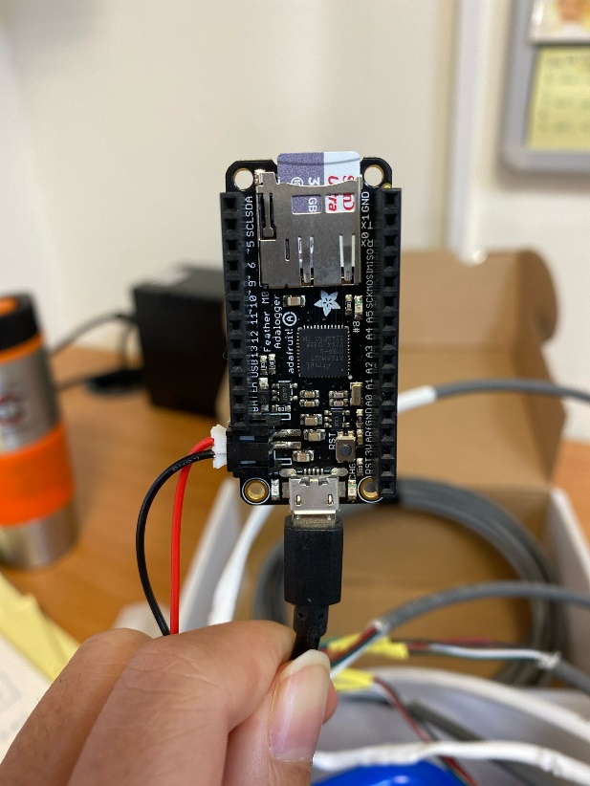 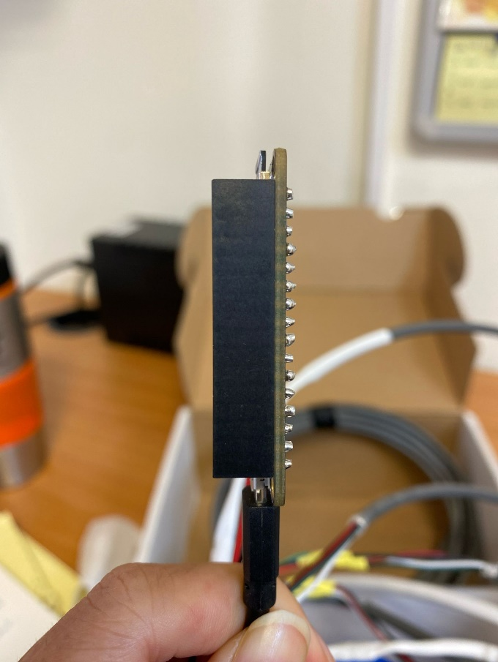

**Step 2: prepare the latching relay Adafruit.**

* The latching relay Adafruit has two pieces, solder 'the small latching piece' (1) to the main part of the relay.
* Solder latching relay Adafruit to male header pins (2). The male header pins and the header 2886 are compatible, creating the communication between the Adalogger and the latching relay Adafruit.

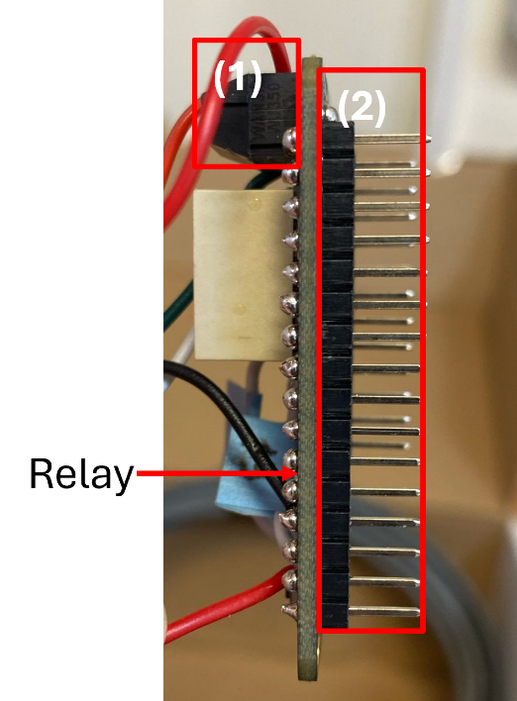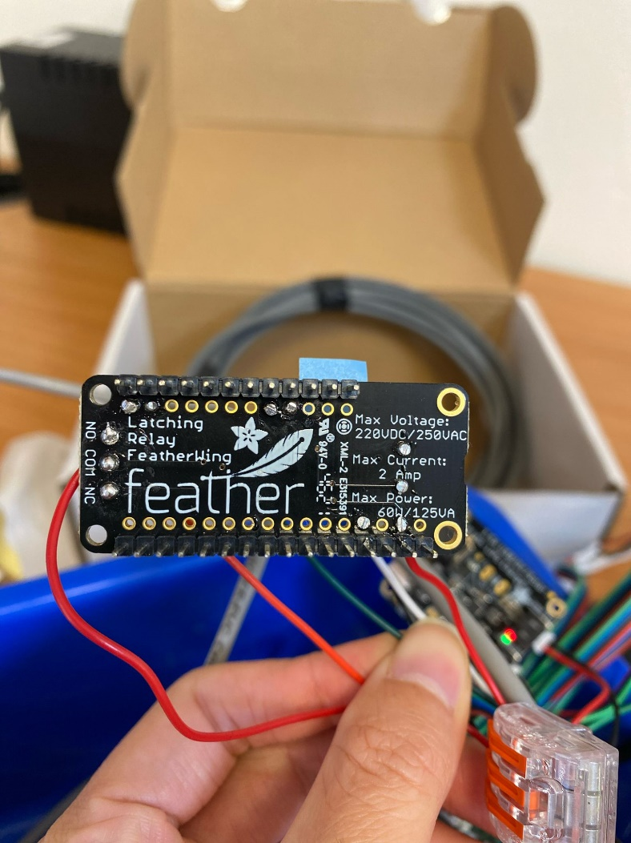

* Solder 2 wires 3-4 cm long connecting:

Port 'set' to port #13

Port 'unset' to port #12

And label them

* Connect 2 red wires 13 cm long to two ports in 'the small latching piece' of the relay.
* Solder 13cm wires in green, white, red, black to following ports:

Green wire to SDA port

White wire to SCL port

Red wire to 3V port

**Black** wire to GND port

These wires will be connected to other parts of the control unit.

|  |  |
| --- | --- |
|  |  |
| The black piece connected with red wires | Latching relay Adafruit after wire soldering |

**Step 3:** **preparing the DFR 0576 multiplexer.**

* Solder 15cm wires in green, white, red, black to following ports of the multiplexer:

Green wire to SDA port

White wire to SCL port

Red wire to 3V port

**Black** wire to GND port

**Step 4: preparing the real-time clock.**

* Solder the DS3231 RTC to a 15cm long 4-pin cable (green, blue, red, black) with a 4pin PH2.0 male header (that compatible to a female port of the multiplexer)

Green wire to SDA port

Blue wire to SCL port

Red wire to 3V port

**Black** wire to GND port

* Insert CR1220 battery into the RTC.

|  |  |
| --- | --- |
|  |  |
| The DS3231 RTC with battery soldered to a 4pin cable | 4pin PH2.0 male header connects the RTC to the multiplex |

**Step 5:** **preparing 128x64 OLED (Adafruit 326).**

* Solder 13 cm wires in green, white, red, black to the following ports of the OLED:

Green wire to data port

White wire to Clk port

Red wire to Vin port

**Black** wire to GND port

* Solder these wires with wires of a Dupont connector:

Green wire to Green wire

White wire to Blue wire

Red wire to Red wire

**Black** wire to **Black** wire

* Protect exposed wires with shrinking sleeves.

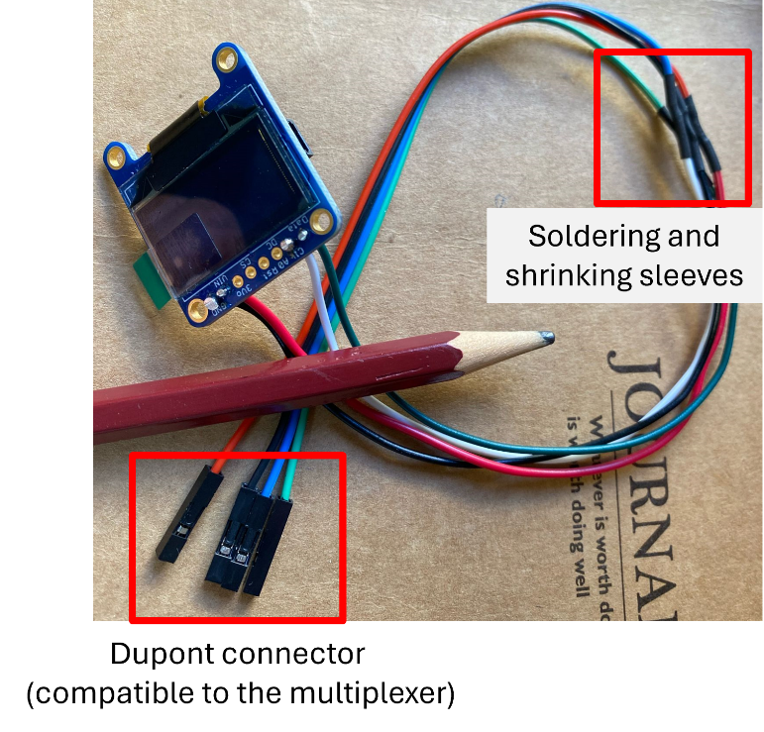

**Step 6: Preparing battery solar panel**

* Extend the cable of the solar panel:

Cut the red cable and expose the red and black wires inside.

Solder the red and black wires with red and black wires of an extended cable.

*\*Please note that the solar panel will be outside in the field conditions, use extra shrinking sleeves and tape to protect the soldered connection.*

|  |  |
| --- | --- |
|  |  |
| The solar panel with extended cable | The solar panel connect to the 1.5A USB solar Lipo charger through a compatible male-female connectors |

* Connect the 1.5A USB solar Lipo charger to:

1. 3.7V 6000MAH battery using a JST PH 2-Pin male connector through port 'Lipo Batt'
2. Latching relay Adafruit using a JST PH 2-Pin male connector through port 'Load Out' (add an on/off switch to the red wire (see pic below))

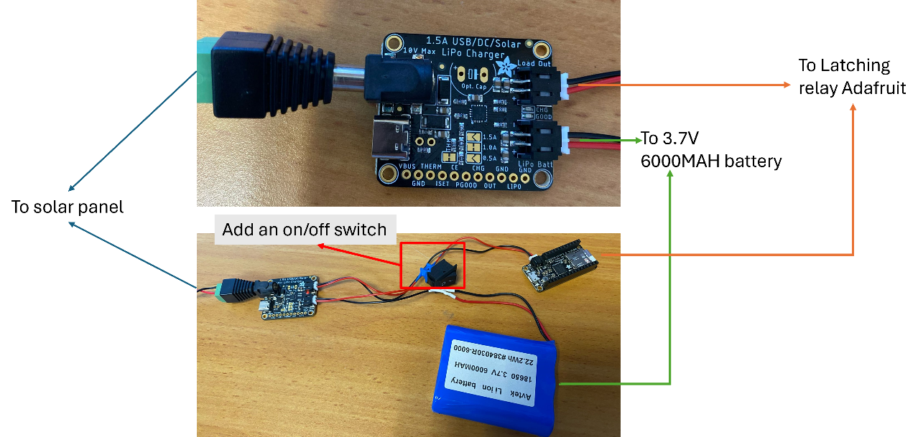

**Procedure (2)**

**Control unit Version 2**

**Step 1: Set up Blues modem by resembling Blues Notecard + Notecarrier + Antenna**

For details, please refer to [Blues website](https://dev.blues.io/quickstart/notecard-quickstart/notecard-and-notecarrier-f/)

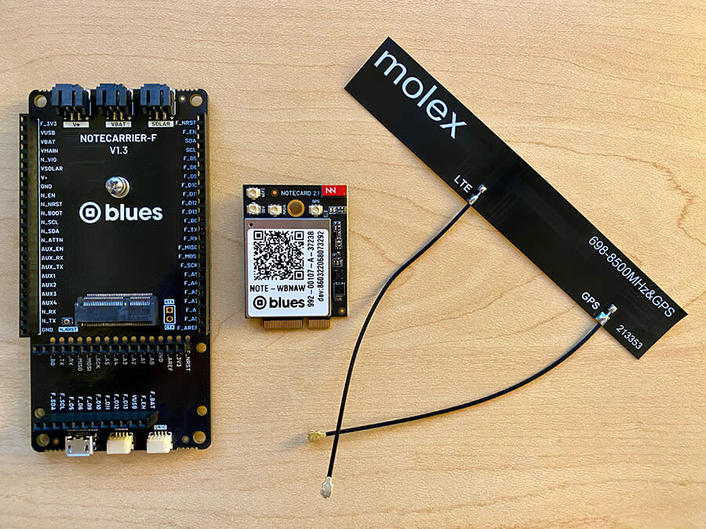

**Step 2**: Stack Adafruit feather M0 + RTC FeatherWing + Blues modem

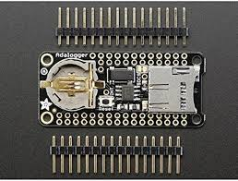 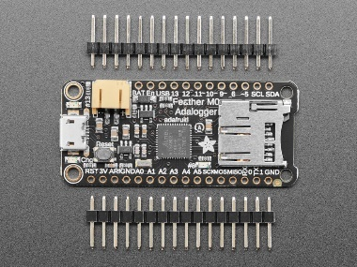 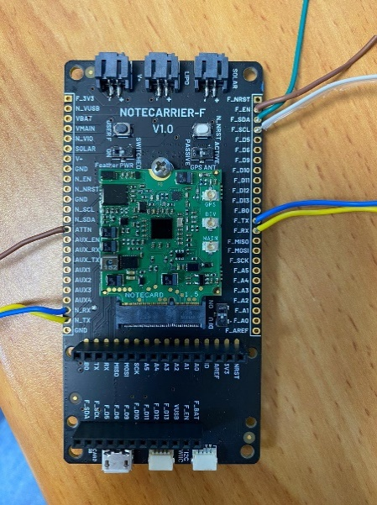

RTC FeatherWing Adafruit feather M0 Blues modem

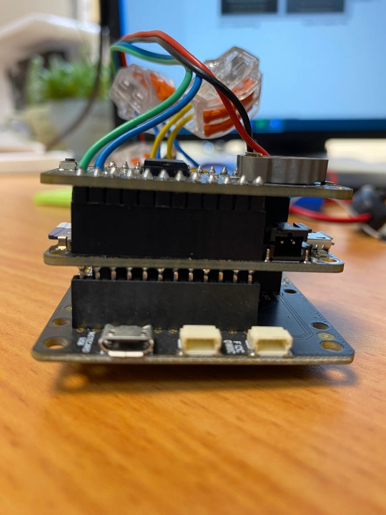

Blues modem

RTC FeatherWing

Adalogger

Soldering is needed to secure the header kit to Adalogger Feather M0 and RTC FeatherWing.

**Step 3: Communicate Adalogger + Blues modem**

* The communication between Blues modem and Adalogger can be I2C or Serial (Serial is suitable when there are a lot of sensors with long cables). Only for Serial communication, these following ports need to be connected.

On the Blues notecarrier:

Connect F_TX 🡪 N_RX (with F stands for Feather and N stands for Notecard)

Connect F_RX 🡪 N_TX

* For power saving, Blues modem can turn Adalogger on and off at desired interval.

For this function, connect F_EN 🡪 ATTN

* Put switches at the back of the Notecarrier as follows:

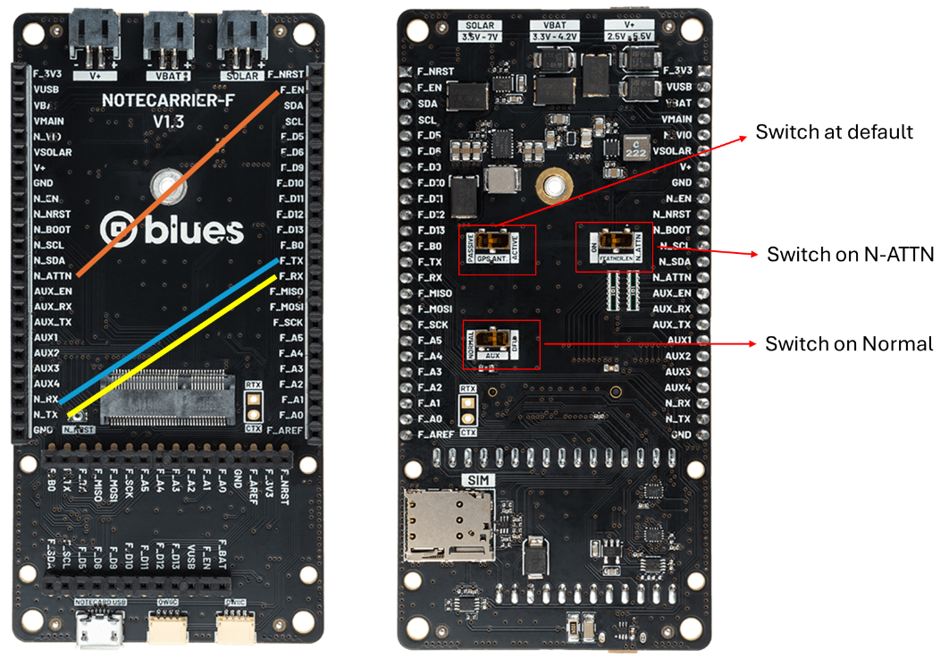

**Step 4: Connecting the control unit to the sensor unit using a multiplexer**

Plug-in the Dupont connector to the matching build-in port on multiplexer

Connect multiplexer to Adalogger feather M0 using a ST PH 4-Pin male connector:

* Solder the black wire to GND
* Solder the red wire to 3V
* Solder the blue wire to SCL
* Solder the green wire to SDA

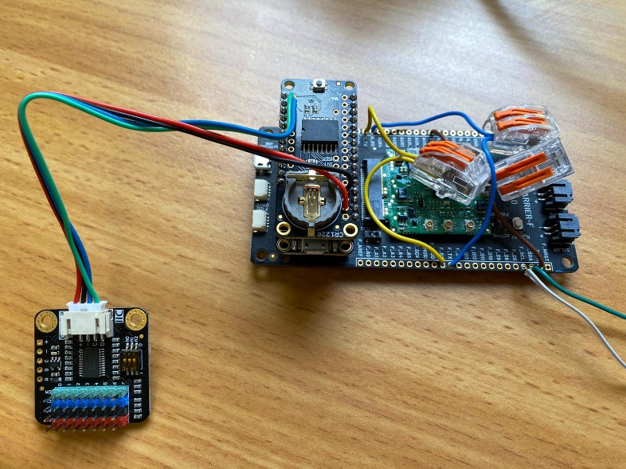

**Step 5: Power the system by chargeable Li ion battery 3.7V 6000MAH and solar panel 6V 6W**

Connect Battery and solar panel to the notecarrier directly using JST PH 2-Pin male connectors as below:

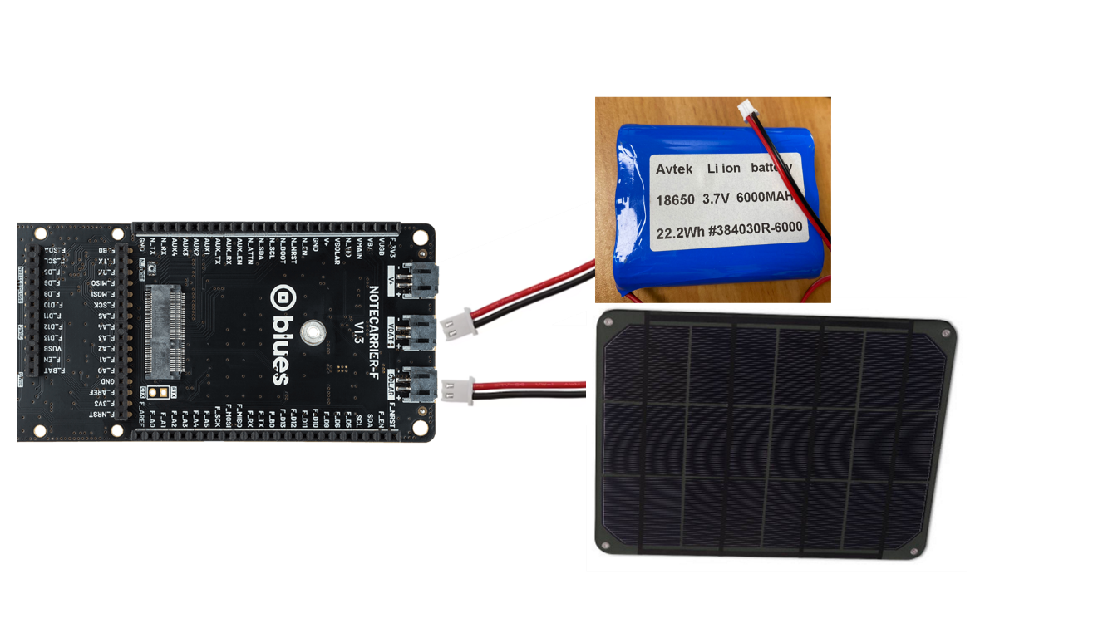

**Step 6: Set up notehub**

For details, please refer to [Blues website](https://dev.blues.io/quickstart/notecard-quickstart/notecard-and-notecarrier-f/#set-up-notehub)

**Step 7: Send notes from notecard to notehub**

* Download our code from [Github](https://github.com/OpenDigiEnvLab/soil-CO2-sensor-system) and upload to Adalogger Feather M0
* 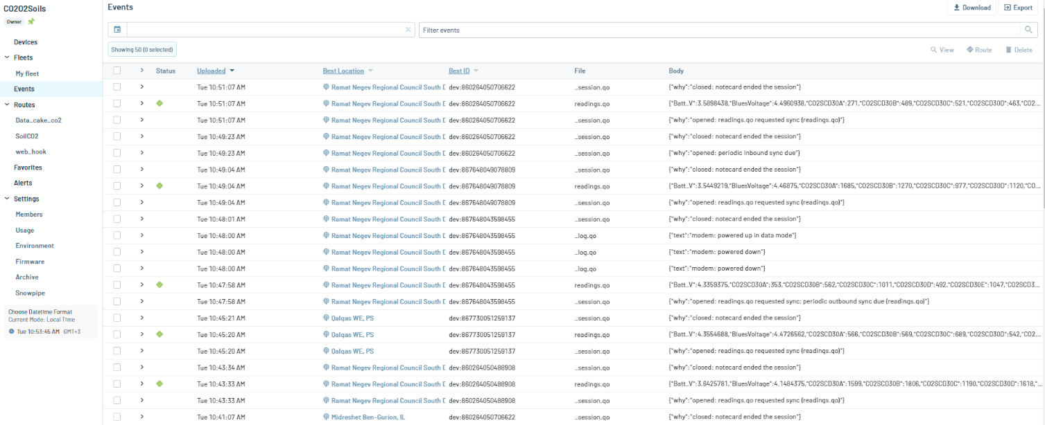Go to <https://notehub.io/projects> and see in your project if your device is connected.

Below is an example of one device with dev:860264050706622 is connected.

**Procedure (3)**

**Thin coating design for waterproofing SCD30 sensor**

To follow, notice that we address each side of the SCD30 sensor as follow:

|  |  |
| --- | --- |
| **Epoxy-filled side** | **Sensor-port side** |
|  |  |

**Step 1: Connect male header pins to SCD30 sensor.**

* Cut and insert 4 [male 90° header pins](https://www.mouser.co.il/ProductDetail/TE-Connectivity/3-826631-6?qs=6Tj7fpyCzVrWp9TSRmZtQw%3D%3D) into VIN, GND, SCL and SDA ports.
* Level the pin head on the sensor-port side to avoid potential damages of the filter from the protruded headers (Tips: put the sensor-port side on a flat surface and push down the pins’ black plastic dividers using a flat-head screwdriver, see pics)

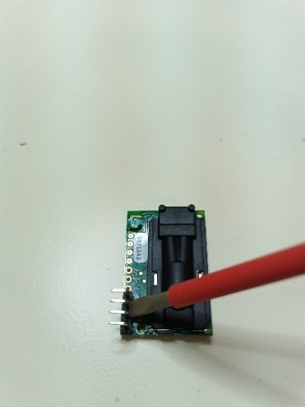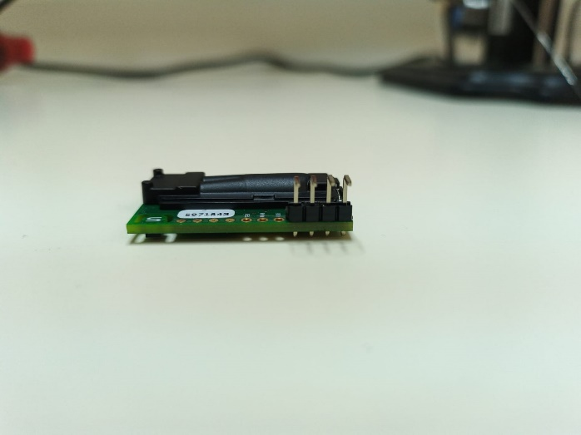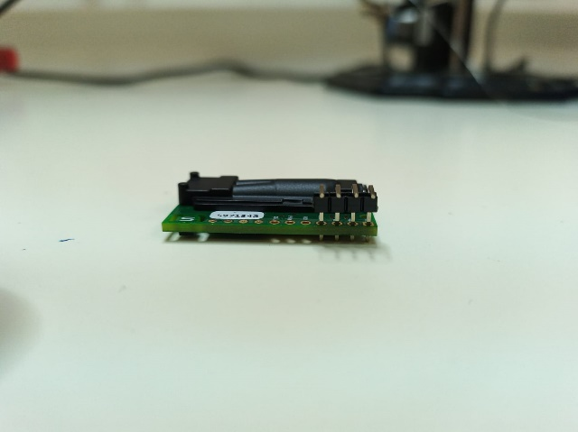

**Step 2: Connecting SCD30 sensor with an extended cable through the male headers.**

* Cut a 3m-long, 4-wire cable, expose 5cm of the cable insulators at both ends, and then expose 3-4 mm of the 4 wires’ insulators, coat wire tips with tin.

One end will be used to connect the sensor to the control unit:

* Solder 4 wires from this end to Dupont connectors (compatible to plug in the multiplexer later on)

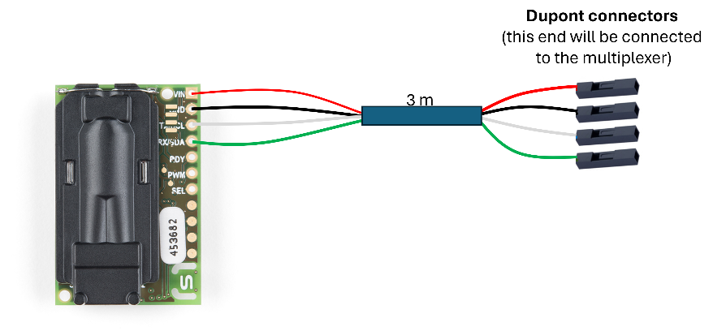

At the other end:

* Put a large shrinking sleeve (that fits over the cable) and 4 small shrinking sleeves over each of the 4 wires.

*\* Make sure that the length of the large sleeve fits from the wires’ edge and ~1cm over the cable insulation, while the small sleeves’ fits over the wires’ insulation and ~3mm more (to fit over the 90° header pins after soldering).*

* Solder the wires to the 90° header pin:

Red wire to *‘VIN’* port

Black wire to 'GND' port

Blue to 'SCL' port

Green wire to 'SDA' port.

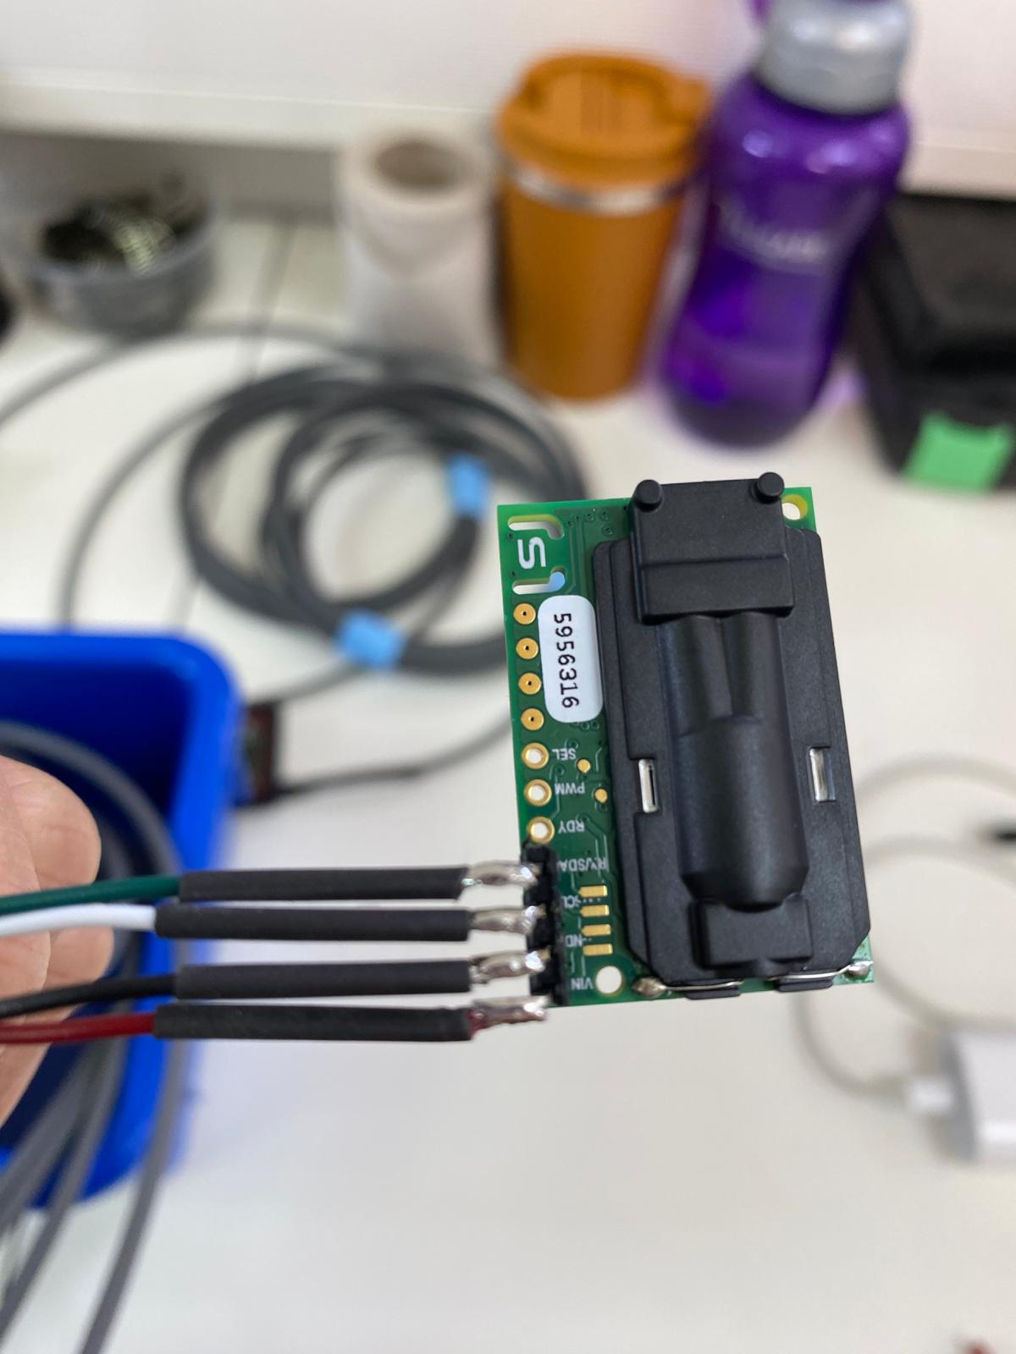

* Thread each of the shrinking sleeves as far down the 90° header pins as possible and shrink them using a blower, then put the large sleeve over the cable insulation and the pins and shrink it in the same way.

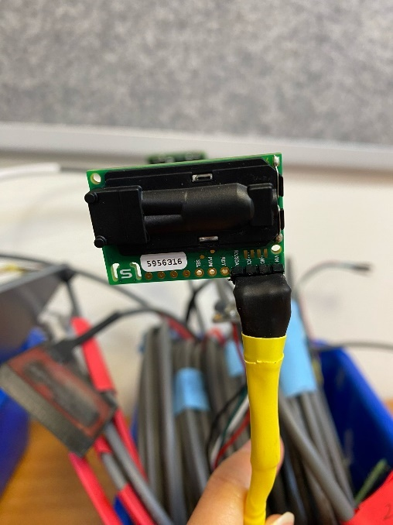

* Take the other end of the cable and expose ~6cm of the cable insulation, then ~3mm of each of the 4 wires’ insulation and coat the exposed wires with tin.
* Check the sensor using *procedure (6).*

**Step 3:** [**Plasti Dip**](https://plastidip.com/product/plastidip/) **sealing**

* The purpose of this [Plasti Dip](https://plastidip.com/product/plastidip/) sealing step is to avoid epoxy block CO2, T- RH ports and damaging the sensor.
* Fit the SCD30 sensor into the 3D printed frame.
* Identify all the openings on the epoxy-filled side that need to be sealed (marked in red).

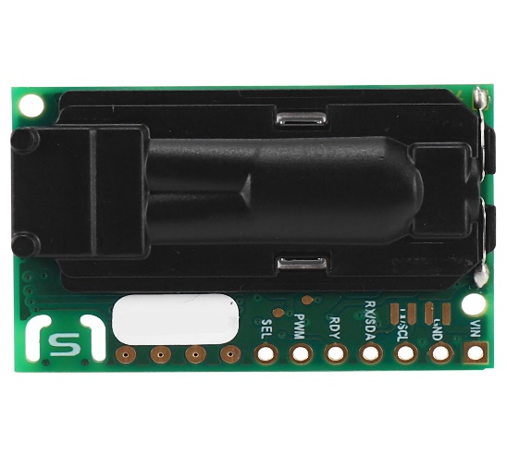

* Stabilize the sensor-frame unit with the epoxy-filled side face up and use a 10cc syringe and a18G needle (1.2x38mm) to slowly and carefully apply Plasti Dip on all the red marked (including the gap between the sensor and the frame, the unused round pin ports, the CO2 ports (**topside only!**), 2 ‘L’ shape openings on both sides of the ‘S’ logo and the 2 holes for griping with spacers).

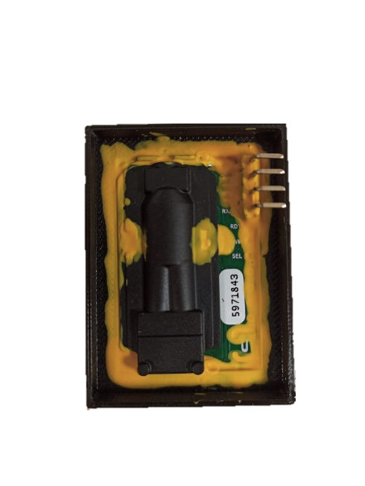

* After drying (~30 mins) make sure no bubbles, shafts or crevasses formed due to the shrinking and drying of the Plasti Dip. If you notice any – seal individually again with Plasti Dip, wait for drying and make sure there are no holes again till it’s sealed.
* Turn the sensor-frame unit with the sensor-port face up, and seal the openings on this side as well (See picture below).

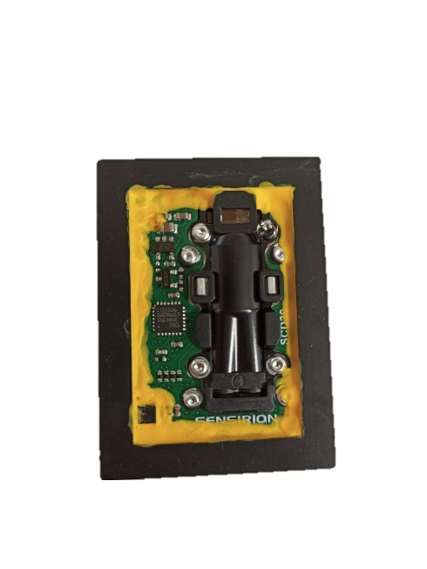

**T – RH**

**sensor opening**

**CO2 sensor**

**openings**

* Check the sensor using *procedure (6).*

**Step 4: Epoxy sealing**

*This step is optional. Instead of epoxy sealing, users can use two PTFE membranes on two sides of the SCD30 sensors (repeat Step 5 on both sides of the sensor)

* Prepare your working environment: put paper towels on a flat, steady surface, stabilize your sensor-frame units in such a way that they’re leveled (so epoxy could be filled to the top of the frame without spilling), use latex gloves while working with epoxy.

** Prepare the mixture: We used a local manufacturer - [Polymer|G](https://www.polymer-g.com/) , mixing the two components EPC 1455: EP 169 in a ratio of 1:5 (can be replaced with any locally available products).

* Weigh 2 gr of EPC 1455 and 10 gr of EP 169 and mix well for at least 2 mins (total 12 gr epoxy should be more than enough for 2 sensor-frame units – working with smaller amount is not recommended).
* Level the sensor-frame unit with the epoxy-filled side face up, pour the liquid epoxy into the frame, on top of the sensor till it reaches the top of the frame without spilling or touching anything else (e.g., your units’ stabilizing setup).

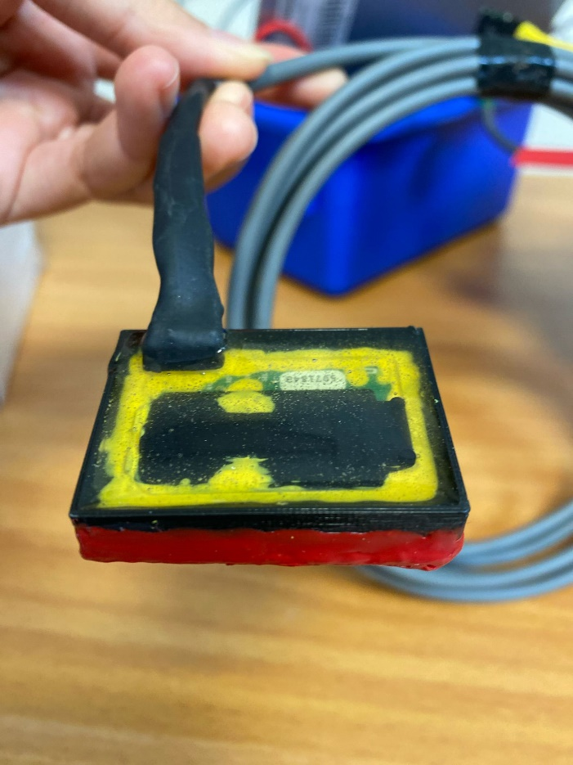

* Wait for it to dry between ½ day and 1.5 days (depending on the environment in which it dries).
* Check the sensor using *procedure (6).*

**Step 5:** PTFE application

* PTEE membrane will be glued to the sensor-port side of the sensor.
* PTEE membrane used in this study is 1/16” x 6” x 6” GR Sheets from [McMaster](https://www.mcmaster.com/ptfe/ultra-chemical-resistant-compressible-ptfe-gasket-material-7/) (95665K92 - 1/16'' thick), which should be cut to match the size of the 3D frame.
* Carefully apply superglue around the frame edges (see pic) and put the cut PTFE on it.
* Apply some pressure by putting a small weight on the PTEE menbrane (see pic), then wait ~20 mins for drying.

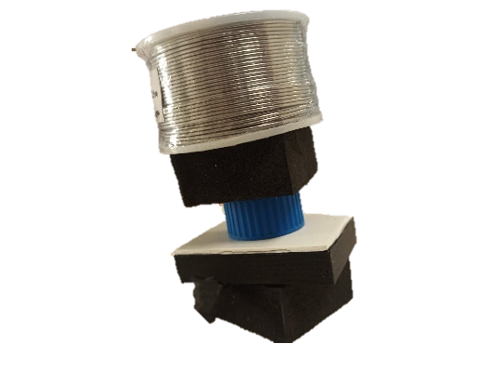

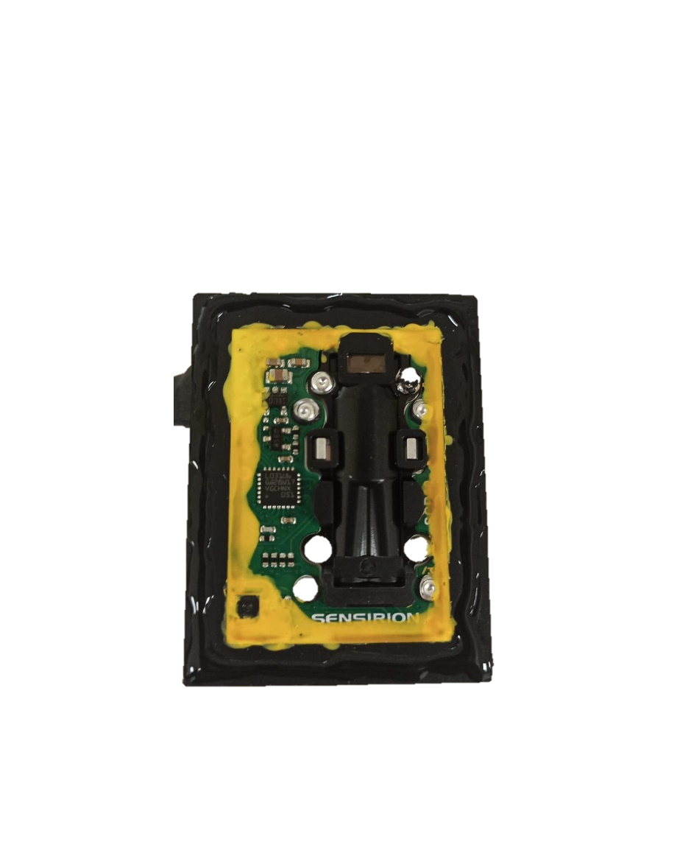

**Superglue spread along the bottom for PTFE application**

* After drying, add one more layer of PlastiDip around the edges between the PTEE membrane and the frame.

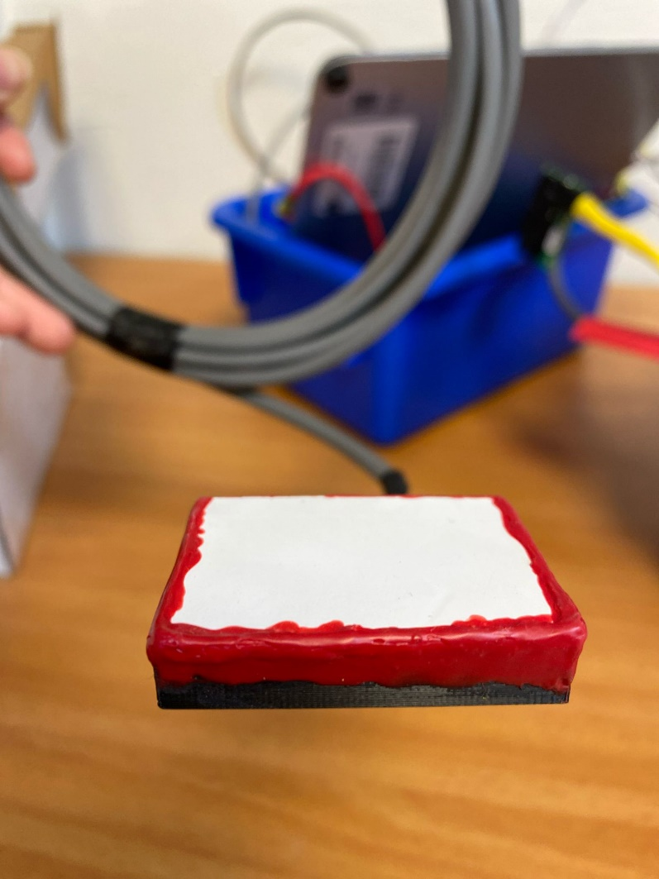

* Check the sensor using *procedure (6).*

**Procedure (4)**

**Falcon tube design for waterproofing SCD30 sensor**

**Step 1: Preparing the Falcon tube.**

* Measure and cut the falcon tube to have a part 6-6.5 cm long from the cap.

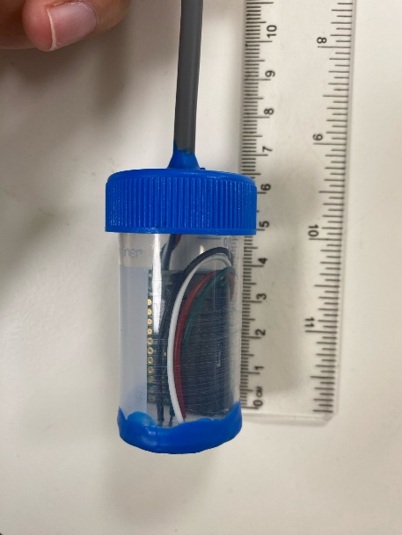

* Drill a hole big enough to pull the 4-wire cable through.
* At the cut end of the tube, cover it with PTEE membrane using superglue (the same membrane as described in the TC design) and seal the edges with PlastiDip (repeat 2 times if needed).

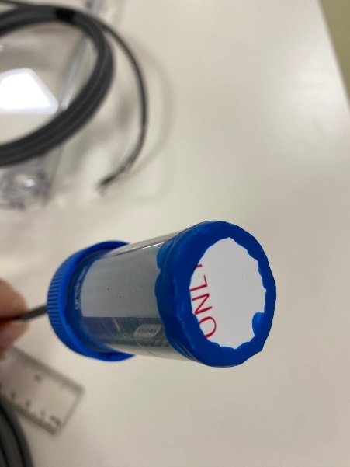

**Step 2: Preparing SCD30 sensor.**

* Use a 4-wire cable 3 m long, exposed 10 cm of the cable insulator at both ends, then exposed 3-4 mm of the wire insulator, coated exposed wire tips with tin.
* First end of the 3m cable: Solder 4 small wiresin colors: green, white, red, black to the corresponding ports on the CO2 sensor (SCD30) in order:

Green wire to SDA port

White wire to SCL port

Red wire to VIN port

**Black** wire to GND port

* Pull the cable through the hole on the Falcon tube's cap so that at the end the SCD30 sensor will be inside the tube.
* Second end of the 3m cable: Solder 4 small wiresin colors: green, white, red, black to 4-pin cable with black female Dupont connectors (see pic below):

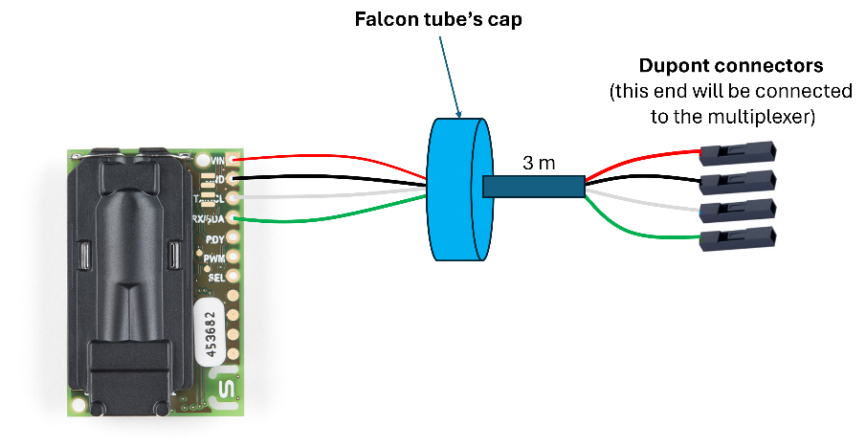

* Seal the edges between the 4-wire cable and the hole with PlastiDip (repeat 2 times if needed).

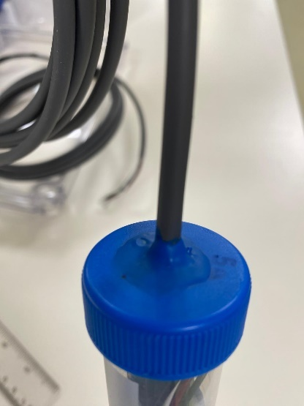

* Put the sensor inside the tube, close the cap and complete waterproofing SCD30 sensor with Falcon tube design.

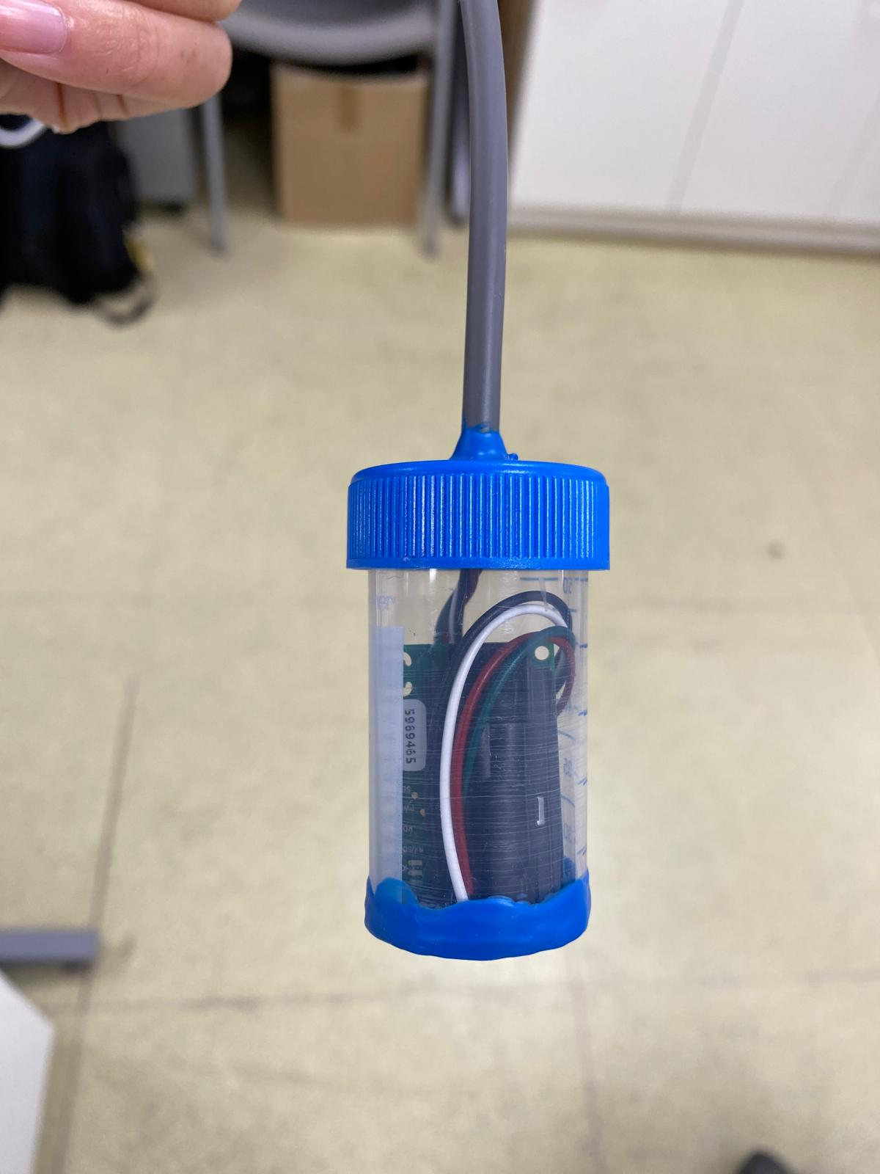

**Procedure (5)**

**Connecting the sensor unit to the control unit version 1 and test the system**

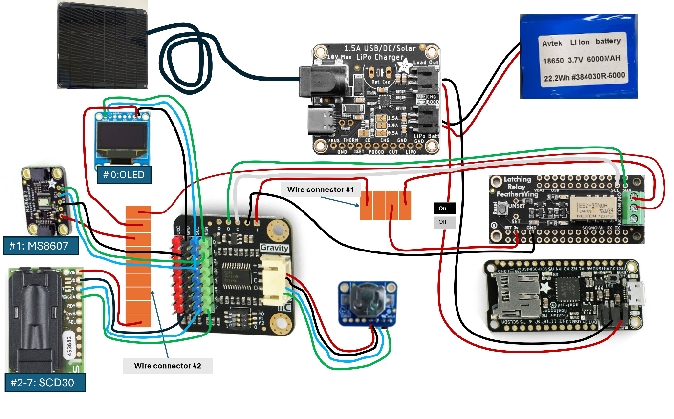

**Step 1: Connect the latching relay to the multiplexer.**

* Solder the **white** wire from the SCL port of the relay to **port C** in the multiplexer.
* Solder the **green** wire from the SCD port of the relay to **port D** in the multiplexer.
* Solder the **black** wire from the GND port of the relay to port ' **–** ' in the multiplexer.

**Step 2: Battery unit**

* Connect the solar panel to the 1.5A USB solar Lipo charger.
* Connect the Li-ion battery to the 1.5A USB solar Lipo charger at "Lipo Batt" port.
* Connect the latching relay-Adalogger unit using the read-made female port on the Adalogger to the 1.5A USB solar Lipo charger at "Load out" port.

**Step 3: The multiplexer**

* Connect the RTC to the multiplexer using a ready-made female port (see pic)
* Connect the green, blue, black wires of the OLED to port#0 of the multiplexer.
* Connect the green, blue, black wires of the MS8607 sensor to port#1 of the multiplexer.
* Connect the green, blue, black wires of the SCD30 to port #2-7 of the multiplexer.

**Step 4: connecting red wires to control power through the latching relay.**

**Wire connector #1 contains:**

* One of the red wires from the 'small latching piece' of the relay.
* Red wire from 3v port of the latching relay.
* Red wire from '+' port of the multiplexer.

**Wire connector #2 contains:**

* The other red wire from the 'small latching piece' of the relay.
* Red wire from the OLED.
* Red wire from MS8607 sensor.
* All the red wires from SCD30 sensors.

Final picture:

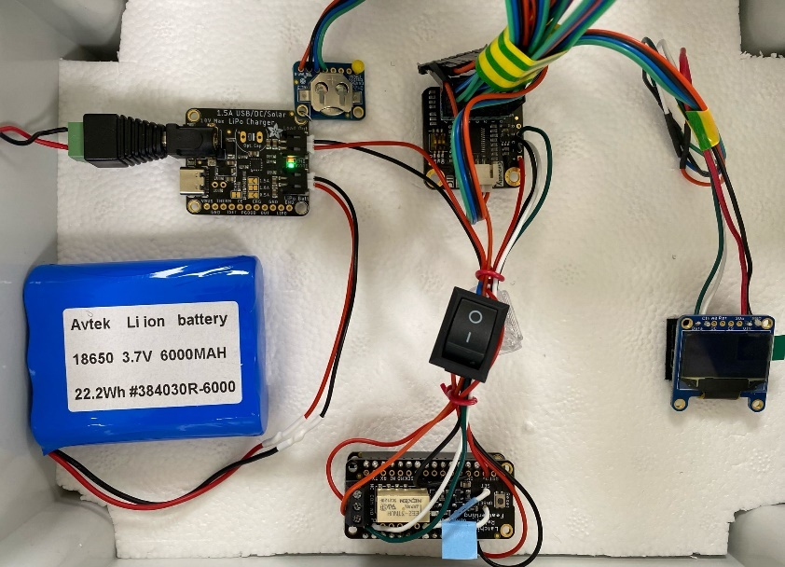

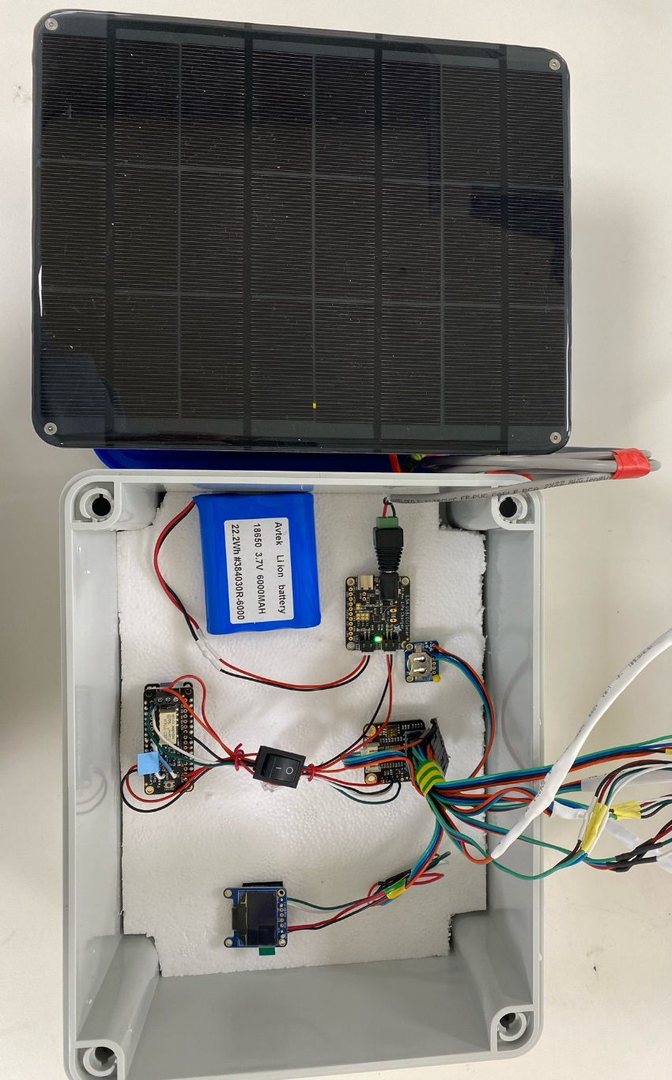

**Step 5: upload the Arduino code file and test the system**

The procedure to upload the code file is similar to *procedure (6)*

**Procedure (6)**

**Embedding Arduino code and checking sensors**

First Timer (internet required):

To make sure that the shielding didn’t damage the sensors you can check them before and after they’re sealed. The following stages are for new users and describe how to connect a PC to a SCD30 using Arduino IDE software to check the sensors:

* Use a logger setup to connect to the sensor, e.g., [Feather M0 adalogger](https://learn.adafruit.com/adafruit-feather-m0-adalogger/overview) and a corresponding [terminal block FeatherWing](https://www.adafruit.com/product/2926) with wires and connectors as needed (See pic on the right), and connect to a PC.

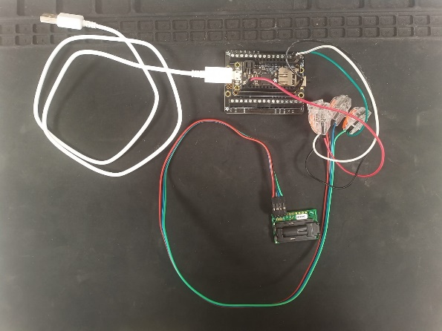

* On a PC open Arduino IDE.
* 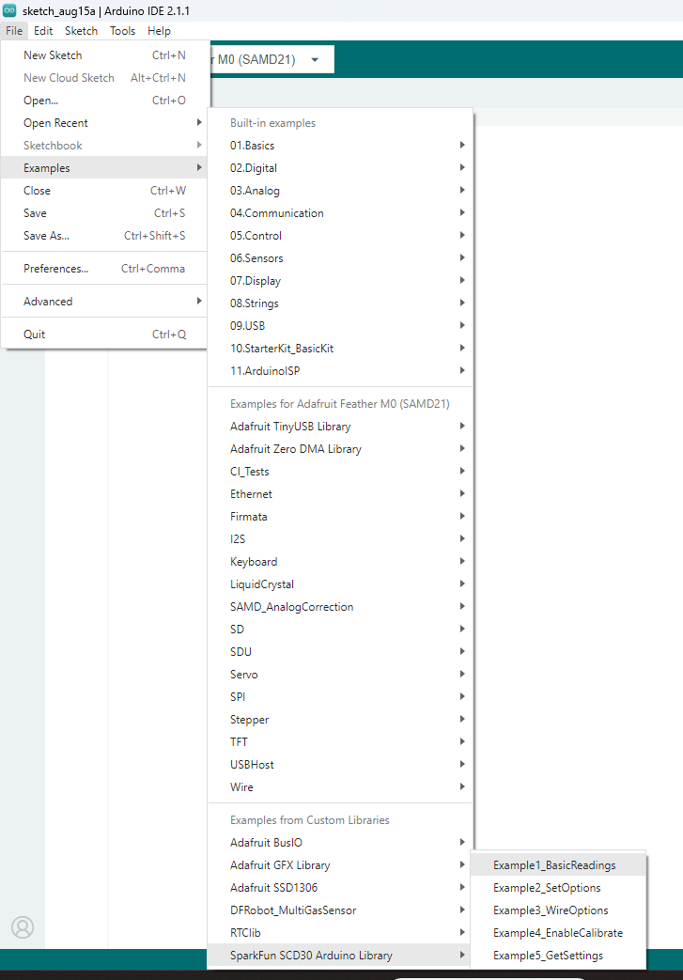Select port and board.
* Install [SparkFun SCD30 Arduino library](https://www.arduino.cc/reference/en/libraries/sparkfun-scd30-arduino-library/).
* Upload SCD30 example code: File/Examples/Examples from Custom Libraries/Example1_BasicReadings.
* Press the *Verify* key and install any boards/libraries that you don’t yet have. Every time you install one, *Verify* again (compiles the code) and you’ll encounter another missing board/library (till no error pops up).

Second Timer

* Connect the SCD30 to the datalogger and the datalogger to a PC (See ‘*First Timer’* section).
* Open Arduino IDE
* Send example code to datalogger by pressing the *Upload* key.
* Open *‘Serial Monitor’* and make sure that all values make sense (Temp, RH and CO2). Blow on the sensor to watch the values change accordingly.